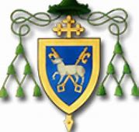

Parish Mass Schedule Christmas 2019
South and East Belfast Pastoral Area

Parish | Christmas Eve | Christmas Day
Holy Rosary: | - 7.00pm  - 10.00pm | - 9.00am  - 10.30am  - 12.00noon
Drumbo & Carryduff | - 7.00pm  - 9.00pm  - 11.00pm | - 9.00am  - 10.30am  - 12.00noon
St Anthony’s  Polish Mass | - 7.30pm  - 9.00pm | - 11.30am  - 9.30am/1.00pm
St Bernadette’s | - 7.00pm  - 10.00pm | - 9.30am  - 11.00am
St Brigid’s | - 10.00pm | - 9.00am  - 10.30am  - 12.00noon
St Colmcille’s | - 7.00pm  - 10.00pm | - 9.30am  - 11.00am
St Malachy’s | - 8.00pm | - 9.30am  - 11.30am
St Matthew’s | - 7.00pm | - 11.00am

