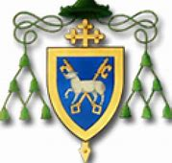

Advent Penitential Services 2019
South and East Belfast Pastoral Community

Parish | Date |  | Time
Holy Rosary: | Monday | 16.12.19 | 7.30pm
Drumbo/Carryduff | Wednesday | 18.12.19 | 7.30pm
St Bernadette’s | Thursday | 19.12.19 | 7.30pm
St Brigid’s | Sunday | 22.12.19 | 4.00pm
St Anthony’s | N/A
St Colmcille’s | N/A
St Matthew’s | N/A
St Malachy’s | N/A

